|  |  |  |  |  |  |  |  |  |  |  |  |
| --- | --- | --- | --- | --- | --- | --- | --- | --- | --- | --- | --- |
| Data set | No. of data | No. of futures | Input variables | Target | Hyper parameter tuning  (n_estimators, max_depth) | Train | | | Test | | |
| R2 | RMSE | MAE | R2 | RMSE | MAE |
| 1 | 100 | 17 | Feedstock, Type, Moisture,  Volatile,  Ash, Proteins, Lipids, carbohydrates,  C, H, N, O, S,  Culture, Condition,  Catalyst, Temperature,  Time, Pressure | Bio oil yield,  HHV,  ERR  Bio oil yield,  HHV,  ERR  Bio oil yield,  HHV,  ERR | RF (200,50)  RF (25,10)  RF (30,10)  DT (- ,20)  ----  DT (- ,10)  ---  LR (Learning Rate=0.01)  --- | 0.94  0.99  0.91  0.81  0.90  0.99 | 0.01  0.003  0.13  4.06  0.46  6.07 | 1.66  0.24  2.17  6.66  5.09  0.24 | 0.80  0.99  0.82  0.62  0.85  0.99 | 0.24  0.01  4.06  34.8  0.48  0.01 | 2.77  0.37  2.8  9.27  58.85  0.28 |
|  |  |  |  |  |  |  |  |  |  |  |  |

***FEATURE IMPORTANCE***

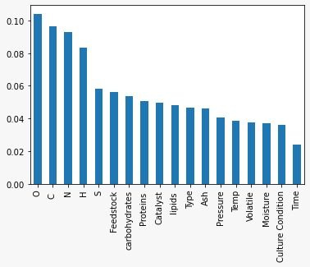

|  |  |  |  |  |  |  |  |  |
| --- | --- | --- | --- | --- | --- | --- | --- | --- |
| **O** | **C** | **N** | **H** | **S** | **FEED-**  **STOCK** | **CARBO-**  **HYDRATES** | **PROTINES** | **CATALYST** |
| **0.12** | **0.098** | **0.093** | **0.087** | **0.058** | **0.057** | **0.055** | **0.053** | **0.052** |

|  |  |  |  |  |  |  |  |  |
| --- | --- | --- | --- | --- | --- | --- | --- | --- |
| **LIPIDS** | **TYPE** | **ASH** | **PRESSURE** | **TEMP** | **VOLATILE** | **MOISTURE** | **CULTURE**  **CONDITION** | **TIME** |
| **0.051** | **0.048** | **0.048** | **0.044** | **0.041** | **0.039** | **0.038** | **0.037** | **0.025** |

***Actual VS Predicted Graph***

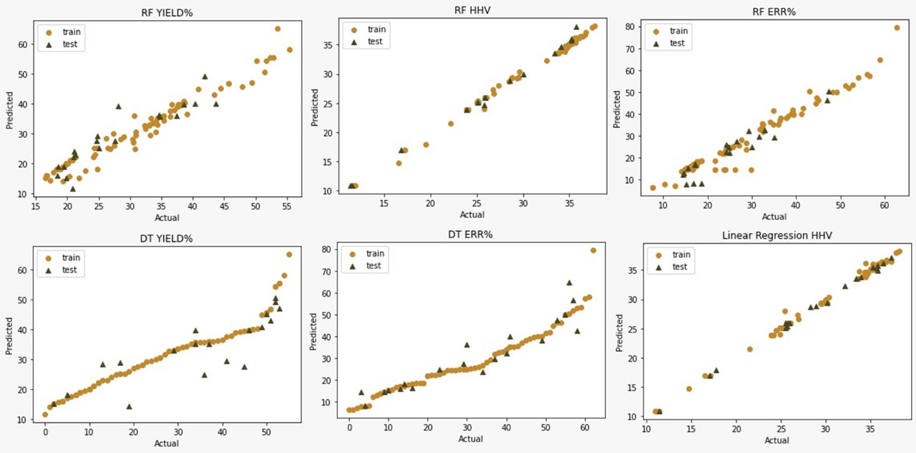

***New Data (Random Forest Yield%)***

|  |  |  |  |  |
| --- | --- | --- | --- | --- |
|  | ***Yield%*** | ***Predicted Value*** | ***Difference*** | ***Predicted Accuracy*** |
| ***Chlorella vulgaris*** | 28 | 31.0 | 3 | 90.3 |
| ***Scenedesmus*** | 27.1 | 30.4 | 3.3 | 89.1 |
| ***Ulva lactua*** | 22 | 21.8 | 0.2 | 99 |
| ***Scenedesmus abundans*** | 34 | 33.1 | 0.9 | 97.3 |
| ***Chlorogloeopsis fritschii*** | 38.5 | 34.0 | 4.5 | 88.3 |

***New Data (Random Forest ERR%)***

|  |  |  |  |  |
| --- | --- | --- | --- | --- |
|  | ***Yield%*** | ***Predicted Value*** | ***Difference*** | ***Predicted Accuracy*** |
| ***Chlorella vulgaris*** | 25 | 29.2 | 4.2 | 85.6 |
| ***Scenedesmus*** | 26.5 | 26.3 | 0.2 | 99.2 |
| ***Ulva lactua*** | 17 | 17.2 | 0.2 | 98.8 |
| ***Scenedesmus abundans*** | 50 | 50.9 | 0.9 | 98.2 |
| ***Chlorogloeopsis fritschii*** | 14 | 22.0 | 8 | 63.6 |

***New Data (Random Forest HHV%)***

|  |  |  |  |  |
| --- | --- | --- | --- | --- |
|  | ***Yield%*** | ***Predicted Value*** | ***Difference*** | ***Predicted Accuracy*** |
| ***Chlorella vulgaris*** | 29.2 | 25.2 | 4 | 86.3 |
| ***Scenedesmus*** | 33.6 | 34.1 | 0.5 | 98.5 |
| ***Ulva lactua*** | 26 | 25.7 | 0.3 | 98.8 |
| ***Scenedesmus abundans*** | 23 | 23.9 | 0.9 | 96.2 |
| ***Chlorogloeopsis fritschii*** | 32 | 25.7 | 6.3 | 80.3 |

***New Data (Decision Trees Yield%)***

|  |  |  |  |  |
| --- | --- | --- | --- | --- |
|  | ***Yield%*** | ***Predicted Value*** | ***Difference*** | ***Predicted Accuracy*** |
| ***Chlorella vulgaris*** | 28 | 29 | 1 | 96.5 |
| ***Scenedesmus*** | 27.1 | 22 | 5.1 | 81.1 |
| ***Ulva lactua*** | 22 | 13 | 9 | 59 |
| ***Scenedesmus abundans*** | 34 | 37 | 3 | 91.8 |
| ***Chlorogloeopsis fritschii*** | 38.5 | 61 | 22.5 | 63.1 |

***New Data (Decision Trees ERR%)***

|  |  |  |  |  |
| --- | --- | --- | --- | --- |
|  | ***Yield%*** | ***Predicted Value*** | ***Difference*** | ***Predicted Accuracy*** |
| ***Chlorella vulgaris*** | 28 | 35 | 7 | 80 |
| ***Scenedesmus*** | 26.5 | 45 | 18.5 | 58.8 |
| ***Ulva lactua*** | 17 | 12 | 5 | 70.5 |
| ***Scenedesmus abundans*** | 50 | 59 | 9 | 84.7 |
| ***Chlorogloeopsis fritschii*** | 14 | 7 | 7 | 50 |

***New Data (Linear Regression HHV%)***

|  |  |  |  |  |
| --- | --- | --- | --- | --- |
|  | ***Yield%*** | ***Predicted Value*** | ***Difference*** | ***Predicted Accuracy*** |
| ***Chlorella vulgaris*** | 29.2 | 26.1 | 3.1 | 89.3 |
| ***Scenedesmus*** | 33.6 | 34.1 | 0.5 | 98.5 |
| ***Ulva lactua*** | 26 | 25.7 | 0.3 | 98.8 |
| ***Scenedesmus abundans*** | 23 | 24.0 | 1 | 95.8 |
| ***Chlorogloeopsis fritschii*** | 32 | 29.8 | 2.2 | 93.1 |